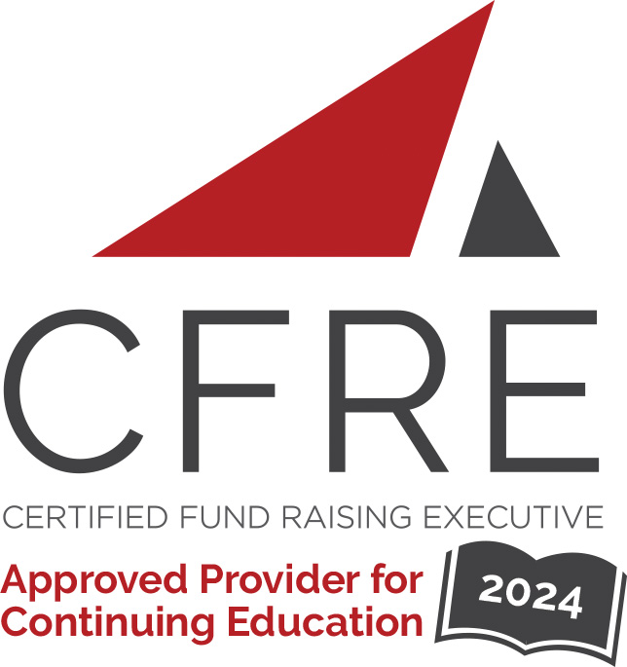 | CONTINUING EDUCATION POINTS TRACKER  CFRE International has developed this form as a way for you to quickly track (and keep in your files!) the continuing education sessions you have attended. Simply check the boxes next to the sessions you attended. At the end of the conference, add up the total number of hours. Keep this sheet and you will be ready to complete your application form. All of the session slots listed are eligible for continuing education points on your CFRE application for initial certification and/or recertification. Sessions not listed here are not eligible for points.

Activity Organizer: - Direct Marketing Association of Washington
Title of Activity: - Nonprofit Fundraisers Symposium
Names of Presenter(s): - Various
Dates and Location: - 20-22 March, 2024 – Washington DC, USA

Date: 21 March 2024
Session 1: 9:15am – 10:30am (1.25 pts)
- Unleash the Innovator Within

21 March Month, 2024
Session 2: 10:45am – 12:00pm (1.25 pts)
- Innovation in the Commercial Sector: What Can Nonprofits Learn and Apply to Fundraising?
- AI Opportunities for Nonprofits: Leverage AI Tools to Create Scale and Impact
- Future-Proofing for a Historic Transfer of Wealth
- Unpack Your Organizational Culture: What is it exactly and how can you improve?
-How to Run Better Meetings

Date: 21 March 2024
Session 3: 12:30pm – 1:30pm (1 pt)
- Nonprofit Transformation, The Smithsonian Institution

21 March Month 2024
Session 4: 1:30pm – 2:45pm (1.25 pts)
- Could Corporate Social Good Make Nonprofits Irrelevant?
- AI Risks for Nonprofits: Ethics, Policy, Data Privacy, Staff Training and More
- Driving Fundraising Innovation Within Your Nonprofit
- Future-Proofing Your Teams for Change & Disruption
-You Don’t Know Me: Lessons and Updates on Data Privacy

Date: 21 March 2024
Session 5: 3:00pm – 4:15pm (1.25 pts)
- Consumer Behaviors Around Money and Impact on Fundraising
- Where We Use AI and Where We Use Humans in Fundraising and Donor Relations
- There’s No Reward Without Risk: Case Studies in High-Risk Creative Breakthroughs
- From the Frontlines: Capitol Hill Day Recap

Date: 22 March 2024
Session 6: 9:00am – 10:15am (1.25 pts)
- The Generation of Performance Benchmarking
- How Decision Science Can Power Your Fundraising
- Sustainability in Direct Mail Fundraising
- AI Opportunities for Nonprofits: Leverage AI Tools to Create Scale and Impact (repeat of 3/21 Session 2)
-You Don’t Know Me: Lessons and Updates on Data Privacy (repeat of 3/21 Session 4)

Date: 22 March 2024
Session 7: 10:20am – 11:45am (1.5 pts)
- Profitable Growth Through Sustainable Innovation

Total number of points attained: __________

